### **Novobeing and Olympian Meeting Announce Strategic Partnership to Enhance Event Wellness Through Virtual Reality**

**BOSTON, June 3, 2025** - [**Novobeing**](https://c212.net/c/link/?t=0&l=en&o=4315988-1&h=2678905354&u=https%3A%2F%2Fwww.novobeing.com%2F&a=Novobeing), a provider of immersive wellness and therapeutic technology, and [**Olympian Meeting**](https://www.olympianmeeting.com/), a pioneer in wellness-centered event design, today announced a strategic partnership to bring integrated, evidence-based well-being solutions to meetings and conferences worldwide.

Under this exclusive agreement, Olympian Meeting will serve as Novobeing’s official event services provider, while Novobeing becomes the exclusive immersive (VR/AR) wellness partner for Olympian Meeting.

This collaboration combines Novobeing’s cutting-edge VR wellness experiences with Olympian Meeting’s expertise in holistic wellness integration at events, enabling a comprehensive, scalable approach to attendee well-being.

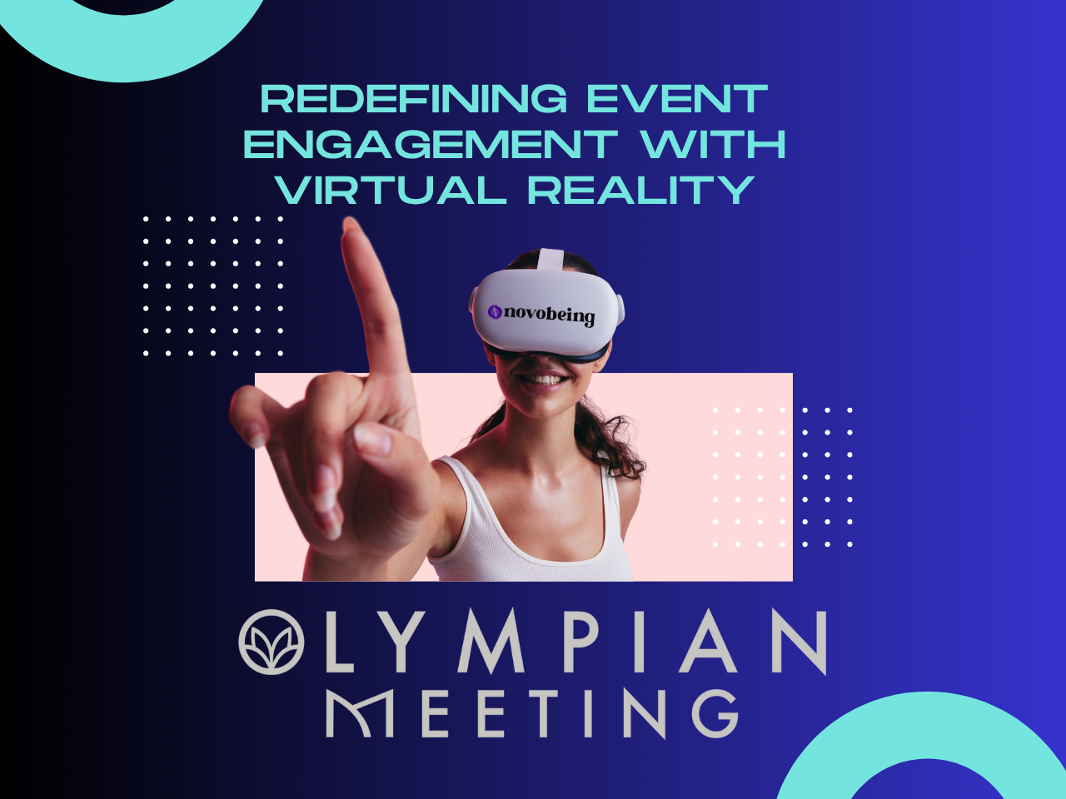

*Novobeing and Olympian Meeting announce an exclusive partnership to deliver immersive, science-backed wellness experiences that enhance focus, reduce stress, and improve engagement at events.*

### **Key Benefits for Event Professionals**

✔ **Science-Backed Wellness** – Integrating immersive VR wellness technology from Novobeing with Olympian Meeting’s proven physical wellness strategies to deliver a holistic event experience.

✔ **Enhanced Attendee Engagement** – Supporting focus, energy, and relaxation through accessible, evidence-based interventions that resonate with modern attendees.

✔ **ROI-Driven Approach** – Demonstrating measurable improvements in attendee satisfaction, productivity, and overall event outcomes through built-in analytics and feedback tools.

✔ **Sustainable & Scalable** – Low-footprint activations designed to fit seamlessly into events of any size or format, without straining resources or disrupting flow.

✔ **Turnkey & Measurable** – Easy-to-deploy solutions with clear usage metrics, real-time reporting, and minimal staffing requirements.

*"We’ve long believed that wellness isn’t a luxury add-on — it’s a strategic advantage,"* said **David T. Stevens**, co-founder of Olympian Meeting and host of the *Return on Wellness* web series. *“Partnering with Novobeing allows us to provide science-backed cutting-edge tools that not only feel good in the moment but yield lasting benefits for attendees and organizers alike.”*

*“From IMEX to Consensus, Collision, and Salesforce, we've brought transformative VR wellness activations to some of the world’s leading conferences — capturing attention, reducing stress, and creating unforgettable moments for thousands of attendees,”* said **Sid Desai**, CEO of Novobeing. *“Now, we're excited to partner with expert event professionals to bring our technology to more people and help make wellness an integral part of the modern event experience.”*

Together, Novobeing and Olympian Meeting are creating a new standard for event wellness — one that combines innovation, simplicity, and proven impact.

**About Novobeing**

Novobeing delivers immersive, evidence-based experiences designed to reduce stress, support mental well-being, and elevate environments through the power of virtual reality. Known for transforming healthcare settings, Novobeing now brings the same approach to events with turnkey wellness activations. Learn more at [novobeing.com/events](https://www.novobeing.com/events)

**About Olympian Meeting**Olympian Meeting is the world only wellness-first event services firm that enhances attendee experience through strategic integration of wellness to drive engagement and attendee performance optimization. With a strong focus on science-based wellness and measurable impact, Olympian Meeting is trusted by top brands and conferences worldwide. Learn more at[olympianmeeting.com](http://olympianmeeting.com).

**Media Contact:** 📧 [hello@novobeing.com](mailto:hello@novobeing.com)  
 📧 [info@olympianmeeting.com](mailto:info@olympianmeeting.com)  
 🌐 [Novobeing.com](http://novobeing.com) | [OlympianMeeting.com](http://olympianmeeting.com)